ADVISORY COUNCIL MEMBER HANDBOOK
Thank you for serving on the Advisory Council; your knowledge and experience is valuable to the continuation of the conference.

- The term of service for Regional Representatives is three years. The term of service for an Alternate Regional Representative is one year.
- Familiarize yourself with the handbook as it will prepare you to serve on the International Women’s Conference (IWC) Advisory Council (AC).
- You are invited and encouraged to attend the Saturday AC meeting where you will receive a copy of the AC binder.
- Your contact on the AC is the New Member Mentor. She will assist you with orientation to the board and answer any questions you may have.
- The AC conducts itself within the framework of AA’s 12 Steps, 12 Traditions, and 12 Concepts for World Service. We encourage you to familiarize yourself with the 12 Concepts for World Service.
- The AC is the custodian of the Conference and is responsible for choosing the future host city and assisting them to assure a successful conference.
- We look forward to working with you on the Advisory Council.

INCLUDED IN THIS PACKET
- List of Responsibilities for Advisory Council Members
- Planning for Next Year’s Conference
- Advisory Council Schedule 2022 - 2023
- Advisory Council Roster 2022 - 2023
- Operating Procedures for the International Women’s Conference, Inc.
- Traditions Checklist
- Concept IV and Concepts Checklist
- AA Guidelines Conferences and Conventions and Roundup

LIST OF RESPONSIBILITIES
- Complete the Advisory Council Member Information sheet provided to you by your Regional Representative at the Regional Meeting
- Attend the Bid Presentations meeting and all AC meetings on Saturday
- Keep confidential all proceedings at the AC meeting including bid information packets. Keep all binders and notes in a secure place and do not engage in AC business discussions outside the AC meeting room.
- AC Members who live in the USA can claim conference expenses (airfare, hotel and meals) on their income tax. They will be given a conference participation sheet signed by the AC Chair. International Reps should make inquiries about claiming expenses in the respective countries.
- Familiarize yourself with the AC binder.
- Throughout the year publicize the conference in your region. Examples are announcing it at meetings, taking registrations flyers to the Intergroup offices and other conferences you may attend.
- You will be contacted by the New Member Mentor once or twice during the year by email or telephone to see if you have any questions.
- Provide any changes to personal information to the New Member Mentor.
- A draft of the meeting schedule, agendas, and minutes of the previous year’s conference will be sent six weeks prior to the annual IWC meeting. Minutes should be read before attending the AC meeting as they will not be read aloud during the meeting.

PLANNING FOR NEXT YEAR’S CONFERENCE
The following are things to consider with respect to the Advisory Council meeting schedule:
- You are expected to attend all of the AC meetings beginning on Thursday morning at 8:00am and ending on Sunday after the speaker.
- Thursday morning breakfast is complimentary; all other meals and banquets are paid by Advisory Council members individually.
- On Friday, a social is held for all past and present Advisory Council members. Attendance is not mandatory however it is an excellent opportunity to meet and hear long time sober women share their experience of the IWC over the years.
- On Sunday after the conference close there is a wrap up meeting with the current Host City Committee and the future Host City Committee. This meeting ends at approximately 1:00pm. Attendance is not mandatory.
- Please keep in mind that you will not be going to panels, workshops, meetings (other than main speaker meetings) and tours as the business of the conference is conducted during the weekend and attendance at the annual meeting is mandatory.
- Plan to book your hotel room and pay your conference registration fee well in advance.
- Book flights or other travel arrangements keeping in mind the time schedule.
- The Host City holds a welcome reception on Wednesday evening. Attendance at the welcome reception is not mandatory

IWC 58TH ADVISORY COUNCIL SCHEDULE
February 15-19, 2023 - Dallas, Texas
Plan to attend ALL meetings shown in RED in the AC Meeting Room, TBD All other sessions are optional.
Wednesday 2/15 | Thursday 2/16 | Friday 2/17 | Saturday 2/18 | Sunday 2/19
 | 8:00 am.  TBD Breakfast Room  8:30am-11:30am  Advisory Council Meeting  Room TBD | 8:00 am.  TBD Breakfast Room  8:30am-11:30am  Advisory Council Meeting  Room TBD | 8:30am-9:30am  BID PRESENTATIONS  ROOM - TBD | 8:00am-9:30am  Breakfast and  Speaker Meeting  Renaissance Dallas TBD
 |  |  | 9:45am-11:30  Advisory Council Meeting | 11:30 am  Conference adjourns
 | 11:30am – 1:30pm  Lunch Break | 11:30am-1:00pm  Lunch Break  IWC Past/Present Chairs Meet/Greet  Room TBD | 11:30am-1:30pm  Lunch Break | 12:00 noon  Wrap up meeting
 | 1:30pm-5:30pm  Advisory Council Meeting | 1:00pm-2:30pm  How to Bid a Conference  Sweeney D | 1:30pm – Conclusion  Advisory Council Meeting
6:00pm-8:00pm  ROOM TBD  Welcome Reception | 5:30pm-7:00pm  Free Time | 3:00 - 5:30 pm  Regional Meetings  Various Rooms TBD | Free Time
 | 7:00 pm  Announcements and Speaker Meeting  Room TBD | 7:00pm  Announcements and Speaker Mtg  Room TBD | 5:30pm Dinner Banquet  Renaissance  7:00pm Speaker Meeting  Room TBD
We do not adjourn until the conclusion of business on Saturday. We close each day with the Responsibility Statement: “I am responsible when anyone, anywhere reaches out for help, I want the hand of AA always to be there, and for that I am responsible.”

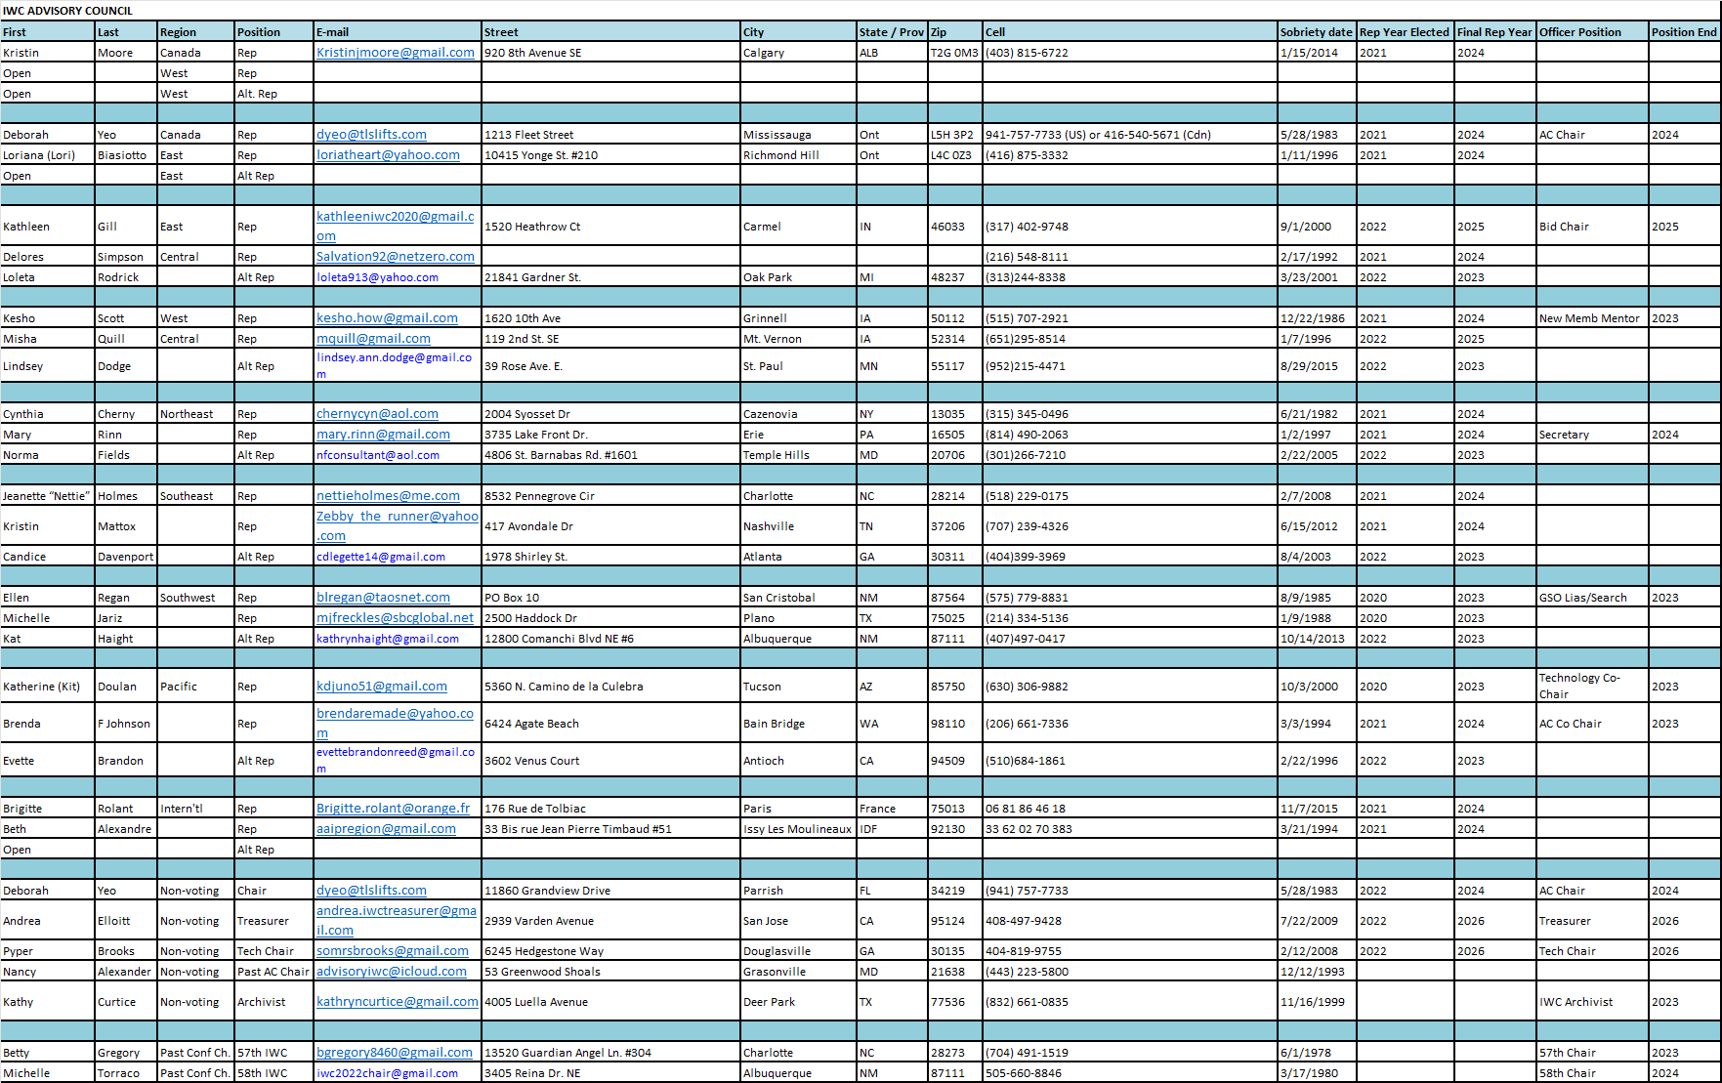

International Women’s Conference, Inc.
OPERATING PROCEDURES

GENERAL
- a. The Host Committee will maintain a post office box for all correspondence.
b. The GSO Liaison will furnish General Services with her current mailing address and a list of current officers and their addresses for any correspondence that is intended for the Advisory Council.
- The Advisory Council will maintain a website, www.internationalwomensconference. org The following domain names are secured by the IWC:
- isaac.org;
- internationalwomensconference.com;
- internationalwomensconference.info;
- internationalwomensconference.net;
- intlwomensconf.org.

The annual domain(s) registration renewal fee and web hosting fees will be paid by the Advisory Council.
- The website and bank accounts shall not be used for any purpose other than Advisory Council business.
- The Advisory Council shall be foremost aware of ensuring the welfare of AA as a whole and shall strictly adhere to The Twelve Traditions of AA, the Twelve Steps and the Twelve Concepts of World Service.
- The Advisory Council shall act as a body and no individual shall make decisions independent of the majority opinion.
- All documents and materials generated by the Advisory Council are proprietary to the Council and shall be retained in permanent form for successive Advisory Councils.
- Any member of the Advisory Council can propose a change to these Bylaws by submitting their request to the chair no less than 60 days prior to the annual meeting. A 2/3 majority will be required for a proposed amendment to the Bylaws to take effect.
- Responsibility for the Past/Present Advisory Board/Council luncheon, which takes place at the conference, will be handled by the Co-Chair if the past chairperson is unable to do it.
- In the event the host city cannot fulfill its responsibilities of hosting a conference as originally bid, the host city will make a recommendation to the Advisory Council to suspend or alter the conference with a minimum of three documented reasons. The host city can present other alternatives to the AC for hosting the IWC, if possible. (i.e. video conferencing, etc.)
- The Advisory Council (or Operating Committee) will meet in an emergency meeting to vote on this action. No formal actions will be taken until the Advisory Council has voted.
- The host city must invoke Force Majeure or Impossibility Clause for any contracts (hotels, conventions centers or other contracts) by sending a letter from an attorney, at the expense of the host city, after the AC has approved the suspension or alteration of the conference.
- If a new format is approved, the host city will establish a budget for the new format for approval by the Advisory Council. A plan for reimbursement of funds collected must be submitted and registrants must be notified of the decision with 30 days of the decision.
FINANCIAL
- The Advisory Council will keep all funds in accounts at Wells Fargo under the name of International Women's Conference Inc. and all financial transactions will be made through these bank accounts.
- The fiscal year of the conference will be from January 1 of the current year until December 31 of the same year.
- All Council members will record expenses on an expense voucher and submit them quarterly with the appropriate receipts to the Advisory Council Treasurer, whether reimbursed or not. Any expenditures exceeding $75.00 must be approved by the Advisory Council Operating Committee.
- The maximum account balance for the prudent reserve is $50,000, of which $2,000.00 will be obtained from the current Host committee at the close of the conference. In the event the prudent reserve of $50,000 limit is reached, the $2,000 prudent reserve payment required from the host city can be suspended. If the host city has lost money from their conference, at the discretion of the Advisory Council, the $2,000 prudent reserve payment can be waived.
- The seed money provided to the next year's Host committee is $8,000.00, which will be obtained from the current Host committee at the close of the conference.
- The seed money provided to the following year's Host committee is $2,000.00, which will be obtained from the current Host committee at the close of the conference.
- The contribution provided to the Advisory Council operating budget is $4,000.00 and can increase by a maximum of 20%, which will be obtained from the current Host committee at the close of the conference.
- The annual premium cost for the registration platform will be reimbursed to the Advisory Council by the 55th Host Committee, if they have the funds. Subsequently, the annual premium cost for the registration platform will be budgeted for and reimbursed to the Advisory Council by the Host Committee.
- The annual update cost of the IWC website will be paid by the Host Committee beginning with the 56th IWC.
BID PRESENTATIONS
- The Advisory Council will be responsible for selecting the future conference Host city two years prior to the event being held in that city.
- The Advisory Council Bid Chairperson will request that bidding cities submit their bids for her review at least one month prior to the conference at which they intend to present their bid.
- Conference bid presenters should prepare 30 packets to be delivered to the AC members by Wednesday afternoon of the conference weekend. If specifically requested by the host city, bid packets can be sent electronically directly to the Bid Chair prior to the conference and the Bid Chair will distribute the electronic bid packet to the Advisory Council.
- Bid presentations will be limited to 15 minutes and should include highlights of the potential host city, basic financial budgets and a contingency plan in the event the conference does not meet its goals.
- Bids will be evaluated according to the following 6 criteria: accessibility of the bidding city, a preference for geographical diversity, adequacy of hotel and meeting space (no other functions scheduled that would have a negative impact on our conference), financial soundness of the bid proposal and the previous conference experience of the bidding committee.
- The “How to Bid a Conference Workshop” will take place Friday afternoon of the conference in a one-hour time slot between 1:30pm and 4:00pm, not to conflict with the Advisory Council luncheon or Regional Meetings, to inform those who are interested in the bidding requirements and the process for putting together a bid for the conference. Advisory Council members are expected to attend this workshop.
- The successful bidding city will be announced at the Saturday night banquet. A post announcement meeting will be held Saturday evening for those cities that did not have successful bids to encourage them to continue working on a bid proposal for a future year and to help them understand the areas in which their bids could be strengthened.
- In the event that no cities choose to present a bid, the following options will be considered:
- The AC will form a contingency committee to ensure there is a host committee or
- Offer Kansas City the opportunity to host the Conference (in the bylaws)
- In the event a bidding city’s bid proposal does not fully meet the six-point bid criteria, the Advisory Council may choose the bid with the understanding that the AC will work with the chosen host city to support and enable them to host the Conference.
TECHNOLOGY
- The Advisory Council (AC) will provide two computers to a host city beginning approximately 22 months before the date of their conference or by June 1st, two years before. The host city will be responsible to return the two computers at the end of that period or April 1 of the same year as their conference. This requires the AC will maintain four computers.
- The computers will be updated as necessary prior to distribution to the host cities. Any of the following may be required: uninstall etc.
- Continue to evaluate a hardware and software technologies to evaluate cloud based office solutions for use by the Advisory Council such as Google Workplace or similar and to provide recommendation(s) to the AC Operating Committee as to the cost and benefit of such solution(s).

Service Material from the General Service Office

TRADITIONS CHECKLIST FROM THE AA GRAPEVINE

These questions were originally published in the AA Grapevine in conjunction with a series on the Twelve Traditions that began in November 1969 and ran through September 1971. While they were originally intended primarily for individual use, many AA groups have since used them as a basis for wider discussion.

Practice These Principles….

Tradition One: Our common welfare should come first; personal recovery depends upon AA unity.
- Am I in my group a healing, mending, integrating person, or am I divisive? What about gossip and taking other members’ inventories?
- Am I a peacemaker? Or do I, with pious preludes such as “just for the sake of discussion,” plunge into argument?
- Am I gentle with those who rub me the wrong way, or am I abrasive?
- Do I make competitive AA remarks, such as comparing one group with another or contrasting AA in one place with AA in another?
- Do I put down some AA activities as if I were superior for not participating in this or that aspect of AA?
- Am I informed about AA as a whole? Do I support, in every way I can, AA as a whole, or just the parts I understand and approve of?
- Am I as considerate of AA members as I want them to be of me?
- Do I spout platitudes about love while indulging in and secretly justifying behavior that bristles with hostility?
- Do I go to enough AA meetings or read enough AA literature to really keep in touch?
- Do I share with AA all of me, the bad and the good, accepting as well as giving the help of fellowship?

Tradition Two: For our group purpose there is but one ultimate authority—a loving God as He may express Himself in our group conscience. Our leaders are but trusted servants; they do not govern.

- Do I criticize or do I trust and support my group officers, AA committees, and office workers? Newcomers? Old-timers?
- Am I absolutely trustworthy, even in secret, with AA Twelfth Step jobs or other AA responsibility?
- Do I look for credit in my AA jobs? Praise for my AA ideas?
- Do I have to save face in group discussion, or can I yield in good spirit to the group conscience and work cheerfully along with it?
- Although I have been sober a few years, am I still willing to serve my turn at AA chores?
- In group discussions, do I sound off about matters on which I have no experience and little knowledge?

Tradition Three: The only requirement for AA membership is a desire to stop drinking.

- In my mind, do I prejudge some new AA members as losers?
- Is there some kind of alcoholic whom I privately do not want in my AA group?
- Do I set myself up as a judge of whether a newcomer is sincere or phony?
- Do I let language, religion (or lack of it), race, education, age, or other such things interfere with my carrying the message?
- Am I overimpressed by a celebrity? By a doctor, a clergyman, an ex-convict? Or can I just treat this new member simply and naturally as one more sick human, like the rest of us?
- When someone turns up at AA needing information or help (even if he can’t ask for it aloud), does it really matter to me what he does for a living? Where he lives? What his domestic arrangements are? Whether he had been to AA before? What his other problems are?

Tradition Four: Each group should be autonomous except in matters affecting other groups or AA as a whole.

- Do I insist that there are only a few right ways of doing things in AA?
- Does my group always consider the welfare of the rest of AA? Of nearby groups? Of Loners in Alaska? Of Internationalists miles from port? Of a group in Rome or El Salvador?
- Do I put down other members’ behavior when it is different from mine, or do I learn from it?
- Do I always bear in mind that, to those outsiders who know I am in AA, I may to some extent represent our entire beloved Fellowship?
- Am I willing to help a newcomer go to any lengths—his lengths, not mine—to stay sober?
- Do I share my knowledge of AA tools with other members who may not have heard of them?

Tradition Five: Each group has but one primary purpose—to carry its message to the alcoholic who still suffers.

- Do I ever cop out by saying, “I’m not a group, so this or that Tradition doesn’t apply to me”?
- Am I willing to explain firmly to a newcomer the limitations of AA help, even if he gets mad at me for not giving him a loan?
- Have I today imposed on any AA member for a special favor or consideration simply because I am a fellow alcoholic?
- Am I willing to twelfth-step the next newcomer without regard to who or what is in it for me?
- Do I help my group in every way I can to fulfill our primary purpose?
- Do I remember that AA old-timers, too, can be alcoholics who still suffer? Do I try both to help them and to learn from them?

Tradition Six: An AA group ought never endorse, finance, or lend the AA name to any related facility or outside enterprise, lest problems of money, property, and prestige divert us from our primary purpose.

- Should my fellow group members and I go out and raise money to endow several AA beds in our local hospital?
- Is it good for a group to lease a small building?
- Are all the officers and members of our local club for AAs familiar with “Guidelines on Clubs” (which is available free from GSO)?
- Should the secretary of our group serve on the mayor’s advisory committee on alcoholism?
- Some alcoholics will stay around AA only if we have a TV and card room. If this is what is required to carry the message to them, should we have these facilities

Tradition Seven: Every AA group ought to be fully self-supporting, declining outside contributions.

- Honestly now, do I do all I can to help AA (my group, my central office, my GSO) remain self-supporting? Could I put a little more into the basket on behalf of the new guy who can’t afford it yet? How generous was I when tanked in a barroom?
- Should the Grapevine sell advertising space to book publishers and drug companies, so it could make a big profit and become a bigger magazine, in full color, at a cheaper price per copy?
- If GSO runs short of funds some year, wouldn’t it be okay to let the government subsidize AA groups in hospitals and prisons?
- Is it more important to get a big AA collection from a few people, or a smaller collection in which more members participate?
- Is a group treasurer’s report unimportant AA business? How does the treasurer feel about it?
- How important in my recovery is the feeling of self-respect, rather than the feeling of being always under obligation for charity received?

Tradition Eight: Alcoholics Anonymous should remain forever nonprofessional, but our service centers may employ special workers.

- Is my own behavior accurately described by the Traditions? If not, what needs changing?
- When I chafe about any particular Tradition, do I realize how it affects others?
- Do I sometimes try to get some reward—even if not money—for my personal AA efforts?
- Do I try to sound in AA like an expert on alcoholism? On recovery? On medicine? On sociology? On AA itself? On psychology? On spiritual matters? Or, heaven help me, even on humility?
- Do I make an effort to understand what AA employees do? What workers in other alcoholism agencies do? Can I distinguish clearly among them?
- In my own AA life, have I any experiences which illustrate the wisdom of this Tradition?
- Have I paid enough attention to the book Twelve Steps and Twelve Traditions? To the pamphlet AA Tradition—How It Developed?

Tradition Nine: AA, as such, ought never be organized; but we may create service boards or committees directly responsible to those they serve.

- Do I still try to boss things in AA?
- Do I resist formal aspects of AA because I fear them as authoritative?
- Am I mature enough to understand and use all elements of the AA program—even if no one makes me do so—with a sense of personal responsibility?
- Do I exercise patience and humility in any AA job I take?
- Am I aware of all those to whom I am responsible in any AA job?
- Why doesn’t every AA group need a constitution and bylaws?
- Have I learned to step out of an AA job gracefully—and profit thereby—when the time comes?
- What has rotation to do with anonymity? With humility?

Tradition Ten: Alcoholics Anonymous has no opinion on outside issues; hence the AA name ought never be drawn into public controversy.

- Do I ever give the impression that there really is an “AA opinion” on Antabuse? Tranquilizers? Doctors? Psychiatrists? Churches? Hospitals? Jails? Alcohol? The federal or state government? Legalizing marijuana? Vitamins? Al-Anon? Alateen?
- Can I honestly share my own personal experience concerning any of those without giving the impression I am stating the “AA opinion”?
- What in AA history gave rise to our Tenth Tradition?
- Have I had a similar experience in my own AA life?
- What would AA be without this Tradition? Where would I be?
- Do I breach this or any of its supporting Traditions in subtle, perhaps unconscious, ways?
- How can I manifest the spirit of this Tradition in my personal life outside AA? Inside AA?

Tradition Eleven: Our public relations policy is based on attraction rather than promotion; we need always maintain personal anonymity at the level of press, radio, and films.

- Do I sometimes promote AA so fanatically that I make it seem unattractive?
- Am I always careful to keep the confidences reposed in me as an AA member?
- Am I careful about throwing AA names around—even within the Fellowship?
- Am I ashamed of being a recovered, or recovering, alcoholic?
- What would AA be like if we were not guided by the ideas in Tradition Eleven? Where would I be?
- Is my AA sobriety attractive enough that a sick drunk would want such a quality for himself?

Tradition Twelve: Anonymity is the spiritual foundation of all our Traditions, ever reminding us to place principles before personalities.

- Why is it a good idea for me to place the common welfare of all AA members before individual welfare? What would happen to me if AA as a whole disappeared?
- When I do not trust AA’s current servants, who do I wish had the authority to straighten them out?
- In my opinions of and remarks about other AAs, am I implying membership requirements other than a desire to stay sober?
- Do I ever try to get a certain AA group to conform to my standards, not its own?
- Have I a personal responsibility in helping an AA group fulfill its primary purpose? What is my part?
- Does my personal behavior reflect the Sixth Tradition—or belie it?
- Do I do all I can do to support AA financially? When is the last time I anonymously gave away a Grapevine subscription?
- Do I complain about certain AAs’ behavior—especially if they are paid to work for AA? Who made me so smart?
- Do I fulfill all AA responsibilities in such a way as to please privately even my own conscience? Really?
- Do my utterances always reflect the Tenth Tradition, or do I give AA critics real ammunition?
- Should I keep my AA membership a secret, or reveal it in private conversation when that may help another alcoholic (and therefore me)? Is my brand of AA so attractive that other drunks want it?
- What is the real importance of me among more than a million AAs?

AA GRAPEVINE INC., 475 Riverside Drive, 11th Floor, New York NY 10115 www.aagrapevine.org

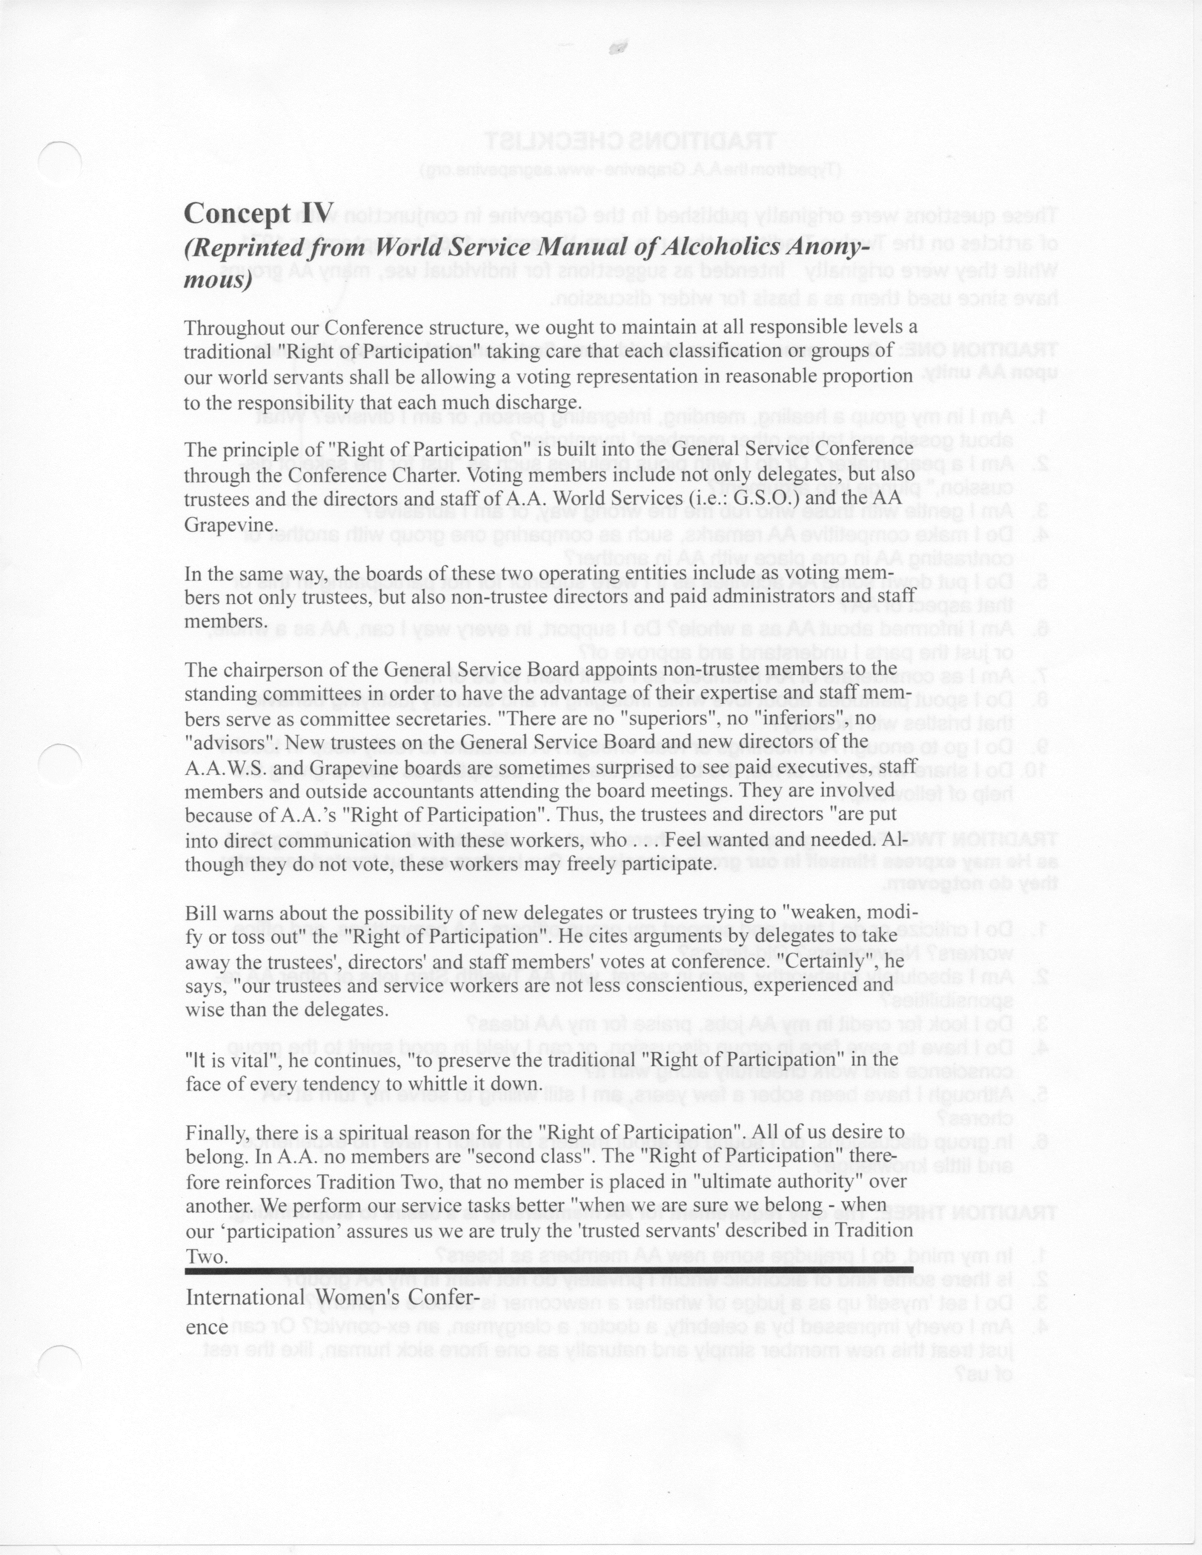 Service Material from the General Service Office

CONCEPTS CHECKLIST

A service piece for home groups, districts, areas
Some of these discussion points were originally developed by an A.A. group and further developed by the trustees’ Literature Committee to be distributed by the General Service Office. While this checklist is intended as a starting point for discussion by groups, districts or areas, individual A.A. members may find it useful along with our co-founder Bill W.’s writings, a service sponsor if you have one and reflection on your own service experience. Additional information about the Concepts can be found in The A.A. Service Manual/Twelve Concepts for World Service and “The Twelve Concepts Illustrated” pamphlet. (The Concepts stated here are in the short form.)

Concept I: Final responsibility and ultimate authority for A.A. world services should always reside in the collective conscience of our whole Fellowship.
- Does our group have a general service representative (G.S.R.)? Do we feel that our home group is part of A.A. as a whole and do our group’s decisions and actions reflect that?
- Do we hold regular group conscience meetings encouraging everyone to participate? Do we pass that conscience on to the district, area, or the local intergroup meetings?
- Is the “collective conscience” of Alcoholics Anonymous at work in my home group? In my area?
- Where do we fit in the upside-down triangle of A.A.?
- Are we willing to do what it takes to insure that our democracy of world service will work under all conditions?
Concept II: The General Service Conference of A.A. has become, for nearly every practical purpose, the active voice and the effective conscience of our whole Society in its world affairs.
- Do we have an understanding of the history of the General Service Conference (the “Conference”)?
- What is a Conference Advisory Action? Does our home group’s G.S.R., D.C.M., area delegate report back to the group on the highlights of the Conference and Conference Advisory Actions?
- Is our group meeting its wider Seventh Tradition responsibilities?
Concept III: To insure effective leadership, we should endow each element of A.A. —the Conference, the General Service Board and its service corporations, staffs, committees, and executives—with a traditional “Right of Decision.”
- Do we understand what is meant by the “Right of Decision”? Do we grant it at all levels of service or do we “instruct”?
- Do we trust our trusted servants — G.S.R., D.C.M., area delegate, the Conference itself?
Concept IV: At all responsible levels, we ought to maintain a traditional “Right of Participation,” allowing a voting representation in reasonable proportion to the responsibility that each must discharge.
- Do we understand the spiritual principles underlying the “Right of Participation”?
- What does “in reasonable proportion” mean? Do we understand when it is appropriate for A.A. paid staff to have a vote at the General Service Conference or in our local service structure?
- Do we expect that, because we are A.A. members, we should be allowed to vote at any group, even if we are not active members of that group?
Concept V: Throughout our structure, a traditional “Right of Appeal” ought to prevail, so that minority opinion will be heard and personal grievances receive careful consideration.
- Do we encourage the minority opinion, the “Right of Appeal,” to be heard at our home group, district committee meetings, area assemblies and the Conference?
- What does our group accept as “substantial unanimity”?
- Has our group experienced the “tyranny of the majority” or the “tyranny of the minority”?
- Does our group understand the importance of all points of view being heard before a vote is taken?
Concept Vl: The Conference recognizes that the chief initiative and active responsibility in most world service matters should be exercised by the trustee members of the Conference acting as the General Service Board.
- Are we familiar with how our General Service Board (G.S.B.) Class A and Class B trustees serve A.A.? Are we familiar with how our other trusted servants serve A.A.?
- Are we clear about the terms, “chief initiative” and “active responsibility”? Can we see a direct link to our home group?
Concept Vll: The Charter and Bylaws of the General Service Board are legal instruments, empowering the trustees to manage and conduct world service affairs. The Conference Charter is not a legal document; it relies upon tradition and the A.A. purse for final effectiveness.
- Do we act responsibly regarding the “power of the purse”?
- Do we realize that the practical and spiritual power of the Conference will nearly always be superior to the legal power of the G.S.B.?
Concept VIII: The trustees are the principal planners and administrators of overall policy and finance. They have custodial oversight of the separately incorporated and constantly active services, exercising this through their ability to elect all the directors of these entities.
- Do we understand the relationship between the two corporate service entities (A.A. World Services, Inc., the A.A. Grapevine) and the General Service Board?
- How can the business term “custodial oversight” apply to the trustees’ relationship to the two corporate service entities?
- Does my home group subscribe to G.S.O.’s bimonthly newsletter Box 4-5-9? A.A. Grapevine? Do I?
Concept IX: Good service leadership at all levels is indispensable for our future functioning and safety. Primary world service leadership, once exercised by the founders, must necessarily be assumed by the trustees.
- Do we discuss how we can best strengthen the composition and leadership of our future trusted servants?
- Do we recognize the need for group officers? What is our criteria for election? Do we sometimes give a position to someone “because it would be good for them”?
- Do I set a positive leadership example?

Concept X: Every service responsibility should be matched by an equal service authority, with the scope of such authority well defined.
- Do we understand “authority” and “responsibility” as they relate to group conscience decisions by G.S.R.s, D.C.M.s and our area delegates?
- Why is delegation of “authority” so important to the overall effectiveness of A.A.? Do we use this concept to define the scope of “authority”?
Concept Xl: The trustees should always have the best possible committees, corporate service directors, executives, staffs, and consultants. Composition, qualifications, induction procedures, and rights and duties will always be matters of serious concern.
- Do we understand how the roles of non-trustee directors and non-trustee appointed committee members help serve and strengthen the committee system?
- How do we encourage our special paid workers to exercise their traditional “Right of Participation”?
- Do we practice rotation in all our service positions?
Concept Xll: The Conference shall observe the spirit of A.A. tradition, taking care that it never becomes the seat of perilous wealth or power; that sufficient operating funds and reserve be its prudent financial principle; that it place none of its members in a position of unqualified authority over others; that it reach all important decisions by discussion, vote, and, whenever possible, by substantial unanimity; that its actions never be personally punitive nor an incitement to public controversy; that it never perform acts of government, and that, like the Society it serves, it will always remain democratic in thought and action.
- How do we guard against becoming a “seat of perilous wealth or power”?
- How do we practice prudent use of our Seventh Tradition contributions and literature revenue?
- Do we insure the spiritual liberties of all A.A. members by not placing any member in the position of absolute authority over others?
- Do we try to reach important decisions by thorough discussion, vote and, where possible, substantial unanimity?
- As guardians of A.A.’s traditions, are we ever justified in being personally punitive?
- Are we careful to avoid public controversy?
- Do we always try to treat each other with mutual respect and love?

